@1
Yes, non-RAPID CT perfusion software can be used to select 4.5-9 hour stroke patients for thrombolysis, but the specific perfusion thresholds must match those validated in clinical trials.
Key Evidence:
The EXTEND trial, which established the benefit of alteplase in the 4.5-9 hour window, used both CT perfusion and MRI perfusion-diffusion imaging with the following criteria: [1]
- Mismatch ratio >1.2 (hypoperfusion to core)
- Mismatch volume >10 mL
- Ischemic core <70 mL (defined as rCBF <30% on CTP or DWI on MRI)
- Hypoperfusion defined as Tmax >6 seconds
The TASTE trial (within 4.5 hours) successfully used MIStar software (Apollo Medical Imaging) at 33 of 35 sites, with only 2 sites using RAPID, demonstrating that non-RAPID software can be used when properly configured. [2] Their criteria used:
- Delay Time >3 seconds (equivalent to Tmax >6 seconds)
- Relative CBF <30% for core
- Mismatch ratio >1.8
- Mismatch volume >15 mL
Critical Requirements:
- Automated postprocessing software is essential—visual assessment alone (as used in ECASS-4) did not show benefit [1][3]
- Standardized thresholds matching trial criteria must be programmed into the software
- Processing time <5 minutes to avoid treatment delays
- The 2026 AHA/ASA guidelines support extended window thrombolysis using "automated postprocessing software analysis" for perfusion imaging, not specifically requiring RAPID [1]
Bottom Line: Non-RAPID software is acceptable if it provides automated analysis with validated thresholds (Tmax >6 sec for penumbra, rCBF <30% for core, mismatch ratio >1.2, core <70 mL). Manual or visual assessment is insufficient.
@1
@2
Surgical evacuation (craniotomy or minimally invasive surgery) is beneficial for ICH in specific clinical scenarios, though the overall evidence remains mixed. The benefit depends on hemorrhage location, volume, patient clinical status, and surgical technique.
Cerebellar ICH - Strongest Indication
Large cerebellar hemorrhages (>3 cm diameter or >15 mL volume) with clinical or imaging signs of brainstem compression or hydrocephalus have the clearest benefit from surgical evacuation. [1-2] This represents a life-saving intervention with demonstrated mortality reduction compared to medical management alone. [1]
The following figure from a large observational study demonstrates the volume-dependent relationship between surgical evacuation and outcomes in cerebellar ICH:
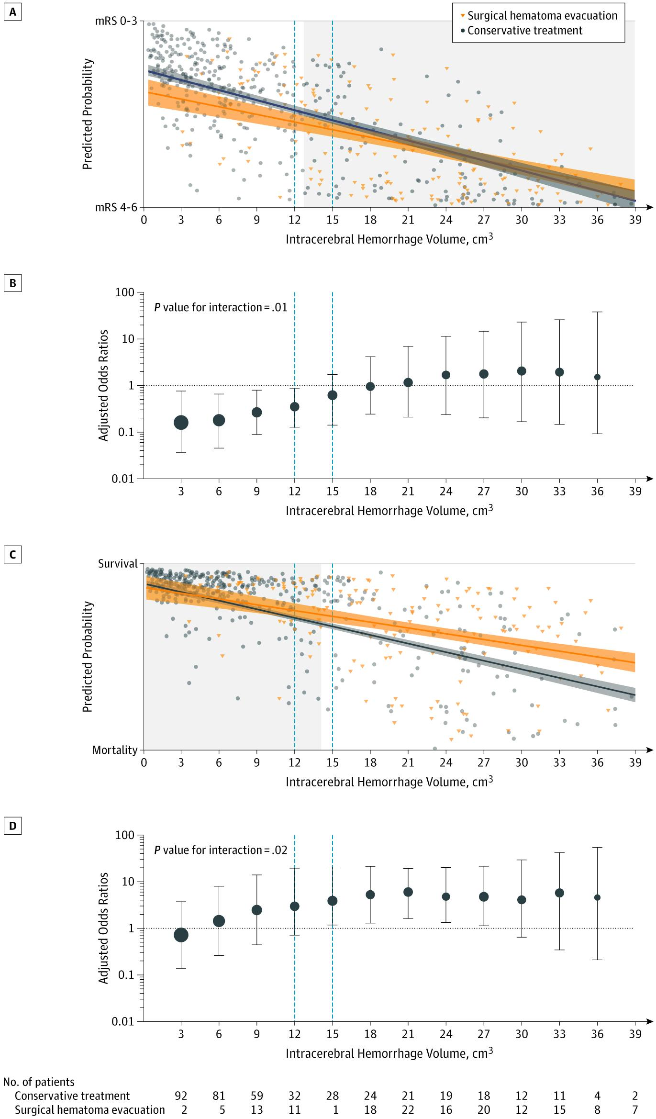
Figure 4. Independent Associations of the Intervention With ICH Volumes
Association of Surgical Hematoma Evacuation vs Conservative Treatment With Functional Outcome in Patients With Cerebellar Intracerebral Hemorrhage. JAMA. 2019年10月8日.
Content used under license from the JAMA Network® © American Medical Association
This analysis reveals that surgical evacuation is associated with improved survival for cerebellar ICH volumes >15 cm³, while paradoxically showing worse functional outcomes for smaller volumes (<12 cm³). [3]
Supratentorial ICH - Selected Patients
Minimally invasive surgery (MIS) shows the most promise for supratentorial ICH with specific patient characteristics:
Patient selection criteria for MIS:
- ICH volume >20-30 mL [1][4-5]
- Glasgow Coma Scale 5-12 [1][4-5]
- Lobar location (stronger evidence than deep ICH) [4]
- Early intervention within 24 hours for lobar ICH [4]
MIS (endoscopic or stereotactic aspiration with or without thrombolytics) may reduce mortality and may improve functional outcomes compared to medical management, though the evidence quality is moderate. [4-5] Recent trials show early functional benefit that may diminish over time. [6]
@2

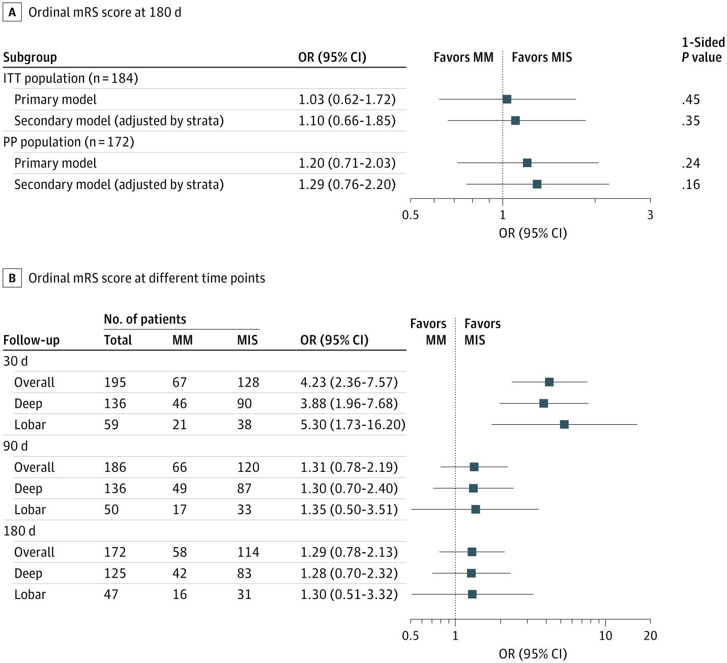
Figure 2. Forest Plot: Ordinal Modified Rankin Scale (mRS) Scores
Minimally Invasive Surgery vs Medical Management Alone for Intracerebral Hemorrhage. JAMA Neurol. 2025年11月1日.
Content used under license from the JAMA Network® © American Medical Association
Craniotomy for supratentorial ICH has uncertain benefit for functional outcomes overall. [1][5] However, it may be considered as a life-saving measure in specific situations:
Indications for craniotomy:
- Deteriorating patients with signs of herniation [4-5]
- Non-comatose patients with lobar ICH when MIS is unavailable [4]
- Superficial lobar ICH within 1 cm of cortical surface (suggested by STICH II) [2]
Decompressive Craniectomy Without Evacuation
Based on the 2024 SWITCH trial, decompressive craniectomy without hematoma removal may be considered for severe deep ICH (volume 30-100 mL, GCS 8-13) to reduce death or severe dependence, though this is a weak recommendation. [4]
Key Contraindications and Cautions
Surgery is generally not beneficial or may be harmful in:
- Small supratentorial ICH (<20 mL)
- Deep coma (GCS <5)
- Very early surgery (<12 hours) due to rebleeding risk [1]
- Patients where the treating neurosurgeon is uncertain about benefit [5]
Summary of Evidence Quality
The 2025 European guideline, 2022 AHA/ASA guideline, and 2020 Chinese guideline all refrain from providing firm recommendations for supratentorial ICH surgery due to very low-certainty evidence. [4] The benefit varies substantially based on ICH location, volume, stroke severity, timing, surgical method, and surgeon experience. [4]
@3
MR spectroscopy: Provides additional diagnostic value by estimating tumor proliferation rate (choline to N-acetyl-aspartate ratio) and necrosis, helping differentiate high-grade from low-grade gliomas with 87% accuracy and distinguishing tumor from non-neoplastic processes.

MR tractography (diffusion tensor imaging): Recommended for surgical planning when the tumor involves eloquent cortex, as it allows localization of cortical functional areas and fiber tracking to minimize postoperative deficits.
The typical clinical DTI protocol uses echo-planar imaging (EPI) sequences with multiple gradient directions (commonly 30-60 directions) and is feasible on standard clinical scanners with multichannel head coils.
CSF cytology: Not routinely indicated in the initial evaluation of suspected primary brain tumors. CSF analysis is reserved for specific scenarios such as suspected leptomeningeal spread or CNS lymphoma
Dexamethasone as initial treatment is associated with worse survival outcomes in glioblastoma patients, despite its effectiveness in reducing cerebral edema and neurological symptoms.
Multiple meta-analyses demonstrate that dexamethasone use correlates with poorer overall survival (HR 1.33-1.62) and progression-free survival (HR 1.48-1.77), particularly at higher doses (≥2 mg/day) and when used during radiotherapy.
Dexamethasone may protect tumor cells from radiotherapy and chemotherapy by inducing anti-proliferative effects that reduce sensitivity to genotoxic stress. [4-5] Additional proposed mechanisms include induction of chemoresistance, suppression of antitumor immune responses, and modulation of DNA damage repair pathways. [5]
Special consideration: If CNS lymphoma is in the differential diagnosis, steroids should be avoided prior to biopsy as they can cause rapid tumor regression and compromise diagnostic yield.
If edema control is needed but steroids are problematic, bevacizumab (anti-VEGF therapy) represents an alternative that does not appear to compromise survival when combined with radiotherapy and may avoid steroid-related complications
CNS lymphoma: The typical location is periventricular white matter, basal ganglia, or corpus callosum.
Differentiating PCNSL from glioblastoma:
Advanced MRI parameters significantly improve differentiation:
- ADC (diffusion): PCNSL shows lower ADC values (0.53-0.66 × 10⁻³ mm²/sec) vs. glioblastoma (0.83-0.98 × 10⁻³ mm²/sec) due to high cellularity [5-7]
- rCBV (perfusion): PCNSL shows lower cerebral blood volume (max rCBV <2.18) vs. highly vascular glioblastoma (max rCBV >2.18), with 98% accuracy [6-7]
- Intratumoral susceptibility signals (ITSS): Present in only 32% of PCNSL vs. 82% of glioblastoma, reflecting less hemorrhage/neovascularization [7]
- MR spectroscopy: PCNSL shows elevated lipid peaks in absence of necrosis (highly specific), higher Cho/Cr and Lip/Cr ratios
Combined evaluation of mean ADC, mean rCBV, and ITSS correctly predicts diagnosis in 95-96% of cases.
A 2025 study of 104 PCNSL patients found no significant difference in diagnostic yield based on time interval between corticosteroid administration and biopsy: [1]
- <48 hours: 96.4% diagnostic yield
- 48-72 hours: 91.7% diagnostic yield
- 72 hours: 100% diagnostic yield
- Overall: No statistical difference (P = 0.658)
Similarly, cumulative dose and duration did not affect diagnostic yield: [1]
- ≤20 mg: 95.5% yield
- 21-40 mg: 100% yield
- 40 mg: 100% yield
- Duration ≤5 days vs >5 days: no difference
The consensus recommendation is to minimize diagnostic delay rather than wait for steroid washout.
CSF cytology remains the gold standard for diagnosing leptomeningeal metastasis, but sensitivity is suboptimal: [1-2]
- First lumbar puncture: 50% sensitivity
- Second lumbar puncture: 75-85% cumulative sensitivity (adds 25% yield)
- Third lumbar puncture: minimal additional yield (~2% incremental benefit)
- Overall detection rate: 70-89% in patients with leptomeningeal disease
autopsy data show ~40% of patients with leptomeningeal metastasis lack positive CSF cytology even with repeated sampling
Even when cytology is negative, other CSF parameters support the diagnosis: [2-3][5]
- Elevated protein (80% of cases, median >50 mg/dL)
- Decreased glucose (<60 mg/dL in 55% of cases)
- Pleocytosis (63% overall; 39% in solid tumors, 57% in lymphoma)
- Elevated opening pressure (>200 mm H₂O in 57%)
- Elevated CSF tumor markers (e.g., CYFRA21-1 significantly higher in CSF than serum)
Metastases are the most prevalent brain tumors overall, representing 30-50% of all brain tumors in adults. [1-2] They outnumber primary malignant brain tumors by approximately 3-10:1 in most series.
Metastases are the most prevalent brain tumors overall, representing 30-50% of all brain tumors in adults. [1-2] They outnumber primary malignant brain tumors by approximately 3-10:1 in most series.
Primary brain tumors have an overall incidence of approximately 6.86 per 100,000 for malignant tumors and 19.19 per 100,000 for non-malignant tumors. [3] Among malignant primary tumors in this age group:
- Glioblastoma is most common (52% of malignant primary tumors), with incidence increasing after age 40 and peaking at ages 75-84 [3-4]
- Lower-grade gliomas (astrocytomas, oligodendrogliomas) typically affect patients younger than 50 [4]
- Primary CNS lymphoma has an incidence of only 0.5 per 100,000 [4]
Clinical presentation favoring primary vs. metastatic:
The seizure presentation provides some diagnostic clues:
- Low-grade gliomas: 58-85% present with seizures [5-6]
- Glioblastoma: 24-50% present with seizures [5-7]
- Brain metastases: 20-35% present with seizures [5]
- Meningioma: ~25% present with seizures
@3

